Data Mining Using R-Language

Ashiat Adeogun
Data Analyst

Table of Contents
1.
Title Page 1
2. Contents……..……..………………………………………………………………………………………………………..………..2
3. Introduction 3-4
4. Research Questions ……………….………………………………………………………………………………………………4
5. Methodology 4-5
6. Keys Findings and Interpretations….……………………………………………………………………………………….5
6.1 The Statistical Summary ……………………………………………………………………………………….5-6
6.2 Checking for Outliers …………………………………………………………………………………………….6-7
6.3 The Categorical Variable Analysis……………………………………………………………………….7-10
6.4 Comparing the 3 scores by the Test Preparation Courses
6.5 The Advanced Statistical Analyzing the Impact of Test Preparation Courses……………10
6.6 Analyzing Parental Education Level Effects ………………………….……………………………11-12
6.7 Analysing Racial/Ethnic Group Differences……………………………………………………….13-14
7. Ethical Considerations ……………………………………………………………………………………………………14-16
8. Recommendations …………………………………………………………………………………………………………16-17
9. Conclusion 17
10. References ………………………………………………………………………………………………………………18

1. Introduction
In the current educational landscape, the importance of data-driven decision-making has never been greater. As schools across the globe strive to improve student outcomes, understanding the multifaceted influences on academic performance is crucial (Reardon, 2018). This analysis delves into how test preparation courses, parental education levels, and racial/ethnic backgrounds impact student achievements in math, reading, and writing. By examining a dataset that encapsulates scores alongside demographic and educational background information, we aim to unearth patterns and insights that could guide educators and policymakers in crafting strategies that enhance learning outcomes.
Test preparation courses are designed to help students improve their academic performance by providing them with strategies to tackle exams more effectively. Our statistical analysis revealed that students who participated in these courses generally achieved higher scores across all subjects than those who did not. This finding supports previous research indicating that structured test preparation can significantly impact student performance due to better preparation and increased confidence (Blackwell et al., 2007)
Educational success is not merely the result of student effort; it is also shaped by external factors that can either support or hinder a student's learning ability. Among these, test preparation courses have been hypothesized to bolster student confidence and improve test-taking skills, potentially leading to better academic performance (Konstantopoulos, 2009). Meanwhile, the role of parental education is often cited as a significant determinant of a child's educational attainment, influencing everything from the richness of the educational environment at home to the expectations parents hold for their children (Davis-Kean, 2005).
Moreover, racial, and ethnic backgrounds play a critical role in shaping educational experiences and outcomes. Students from minority backgrounds often face systemic barriers that impact their academic journeys. These can include access to fewer educational resources, lower levels of parental education, and higher rates of enrollment in under-resourced schools (Wickham & Wickham, 2016) By identifying and understanding the extent of these influences, stakeholders can better address inequalities and implement effective educational practices.
This study utilizes advanced statistical techniques to analyze how these variables interact and affect academic performance across different demographic groups. The insights derived from this research could highlight areas needing targeted interventions and help develop comprehensive strategies addressing educational disparities' root causes.
Through rigorous analysis of the dataset, this report seeks to offer actionable insights that help educational stakeholders make informed decisions. By providing a clearer picture of the educational landscape through the lens of data, the aim is to contribute to the ongoing discussion about educational equity and effectiveness. The goal is to ensure that all students, regardless of background, have access to the opportunities and support they need to succeed academically. This not only aids individual students but also strengthens the educational system, promoting a more informed and equitable society.

2. Research Questions
- Does participation in a test preparation course correlate with higher scores in math, reading, and writing?
- How does parental level of education affect student performance across math, reading, and writing scores?
- Are there significant differences in performance across different racial/ethnic groups in these subject areas?
3. Methodology

In our study, we leveraged R, a comprehensive and robust statistical software environment, recognized for its extensive capabilities in both analysis and visualization, to delve into the complexities affecting educational outcomes. R's diverse array of packages and functions facilitates a thorough approach to both descriptive and inferential statistics, making it the preferred tool for our analysis (Wickham & Wickham, 2016).
During the inferential phase of our research, we utilized t-tests to evaluate differences in mean scores between groups, specifically investigating the impact of test preparation courses on academic performance. This was crucial in determining whether students who engaged in preparatory courses fared better in assessments compared to their counterparts who did not.
Further expanding our analysis, we applied ANOVA techniques to assess variations across multiple groups, focusing particularly on how different racial and ethnic backgrounds influence student performance. This aspect of our study is vital for identifying broader educational disparities and pinpointing areas needing targeted interventions.
Additionally, regression analysis played a pivotal role in our investigation, enabling us to explore how parental education levels affect student academic achievements across various subjects. By incorporating multiple variables, we could better understand the interplay between home environment and educational success, providing a clearer picture of the external factors that contribute to academic outcomes (James et al., 2013).
To ensure that our findings were clearly communicated and readily interpretable by both educators and policymakers, we utilized the ggplot2 package in R for data visualization. Renowned for its ability to produce elegant and complex graphics, ggplot2 allowed us to represent our data visually in a manner that was not only accessible but also meaningful (Reardon, 2018) The visuals created helped underscore our statistical conclusions, facilitating a deeper understanding of the data and enhancing the overall impact of our research. These visual aids are crucial for presenting complex data sets in an understandable format, thus aiding in decision-making processes that could shape future educational strategies.
This comprehensive approach using R and its visualization capabilities ensures that our research is both scientifically robust and practically relevant, providing valuable insights into how educational strategies can be tailored to meet diverse student needs.

4. Key Findings and Interpretations

The analysis revealed several key findings. Firstly, students who engaged in test preparation courses consistently achieved higher scores across all subjects. Additionally, higher parental education levels were closely correlated with better academic performance, particularly in reading and writing. Significant disparities were also observed among different racial/ethnic groups, highlighting the need for customized educational support. Figure 1 shows the dataset which consists of 6 features.

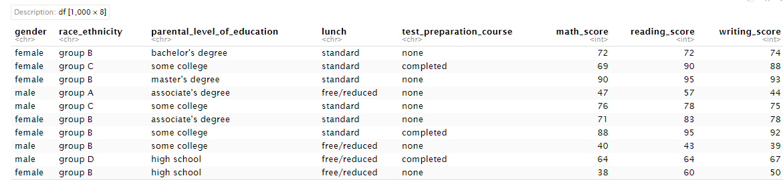
Figure 1: The dataset

4.1: The Statistical Summary
The dataset consists of 1,000 student entries, capturing a range of demographic and educational variables including gender, race/ethnicity, parental level of education, lunch status, and test preparation course involvement. Academic performance is quantified through scores in math, reading, and writing. Math scores vary widely from 0 to 100, suggesting a range of competencies or possibly data entry errors for minimum scores. Reading scores start higher at 17 and also cap at 100, while writing scores span from 10 to 100, both aligning closely with the median values around 70. This suggests a generally higher performance in these areas compared to math. The mean scores are situated in the mid to high 60s, highlighting an average performance that might mask underlying disparities or educational impacts from the captured socio-economic and preparatory variables as shown in Figure 2.

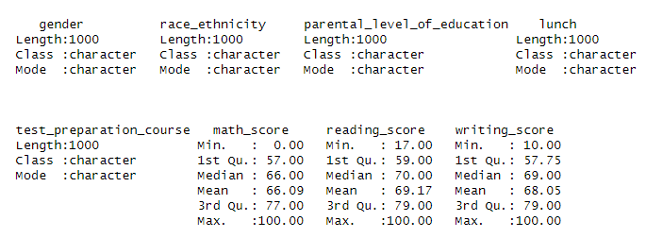
Figure 2: The Statistical Summary.
4.2 Checking for Outliers
As displayed in Figure 3, the boxplots of math, reading, and writing scores depict a common pattern with a cluster of low outliers in each subject, suggesting either data entry errors or a small group of students significantly underperforming. The median scores for math and writing are approximately 75 and 70 respectively, indicating that half of the students scored below these marks. Reading scores have a slightly higher median around 75, reflecting a somewhat better performance in this subject area.

The interquartile ranges (IQR) are quite narrow in all three subjects, indicating that the scores of most students are grouped relatively close together. This suggests a consistent performance across the middle 50% of the students. However, the existence of outliers, particularly in the lower range, indicates extreme cases that could skew the overall data interpretation and might require special attention either for academic support or data validation to ensure accuracy.

In summary, while most students perform within a similar score range, the significantly lower outliers across all subjects warrant further investigation to support those students or to correct potential data issues.
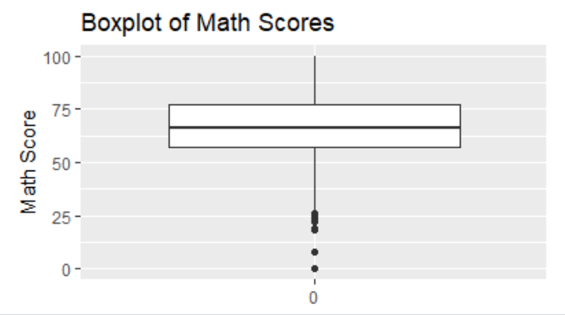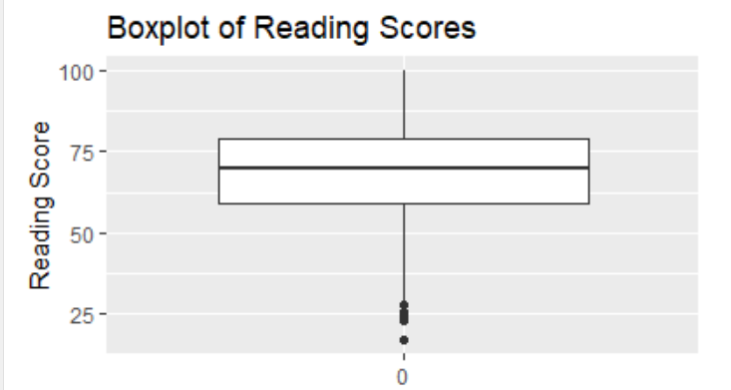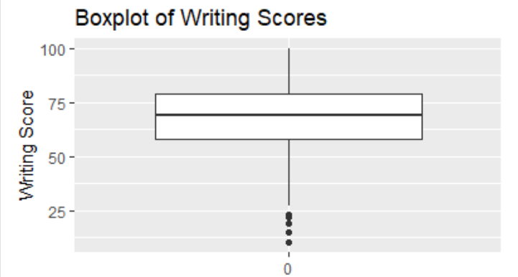

Figure: The Boxplot for the three courses

The outliers identified in the dataset for math, reading, and writing scores are significantly below the average scores of the cohort. Math scores have outliers as low as 0, with values ranging up to 26, indicating extreme underperformance or data entry errors. Reading and writing scores show similar patterns, with the lowest outliers at 17 and 10 respectively. These outliers are crucial for understanding the range of student abilities and possibly identifying students who may require additional support or interventions. They also highlight the need for reviewing the data collection and entry processes to ensure the accuracy and reliability of the dataset as shown in Figure 4

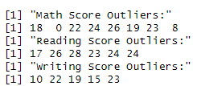
Figure 4: The Summary of the Outliers

4.3 The Categorical Variable Analysis

The boxplots display math scores distributed by gender, race/ethnicity, and parental education level. Males slightly outperform females with a few lower outliers indicating variability. Race/ethnicity impacts scores significantly, with Group E showing the highest medians and Group A the lowest, suggesting disparities based on racial backgrounds. Students with parents holding higher educational degrees, like a master's, typically score higher, reflecting the influence of parental education on academic achievement. These visualizations highlight the necessity of addressing educational inequalities and tailoring interventions to support underperforming groups based on these sociodemographic factors as shown in figures 5 and 6 representatively

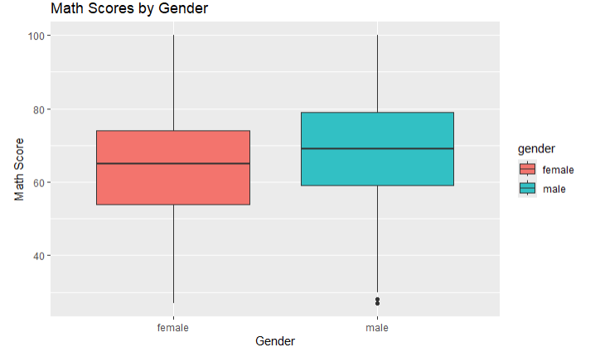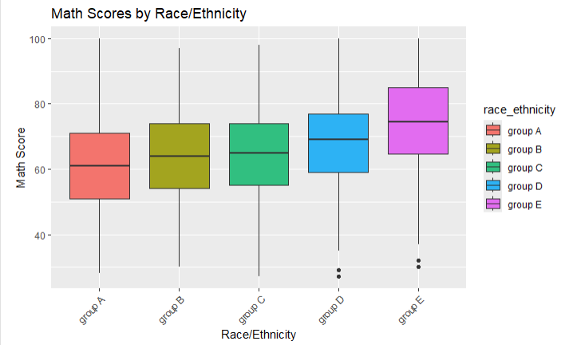
Figure 5: The boxplot of Math scores for gender and race.
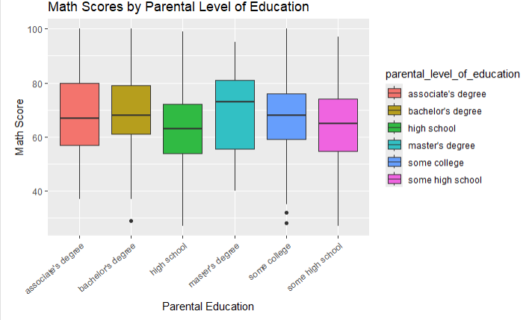
Figure 6: The boxplot of Math scores for parental level of education.

The boxplots reveal differences in reading scores across genders and parental education levels. Females generally exhibit higher median reading scores compared to males, indicating a gender disparity in reading performance. Among parental education levels, students with parents holding a master's degree show the highest median scores, suggesting that higher parental education correlates with better academic outcomes in reading. Conversely, students whose parents have only some high school educations tend to score lower, highlighting the potential impact of parental education on student achievement. These insights underscore the importance of educational support at home in influencing student performance as shown in figures 7 and 8 representatively.

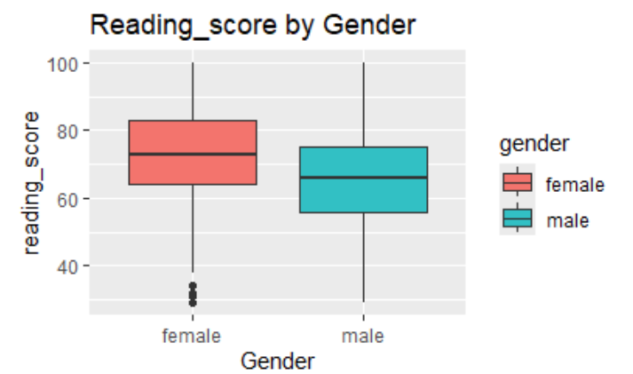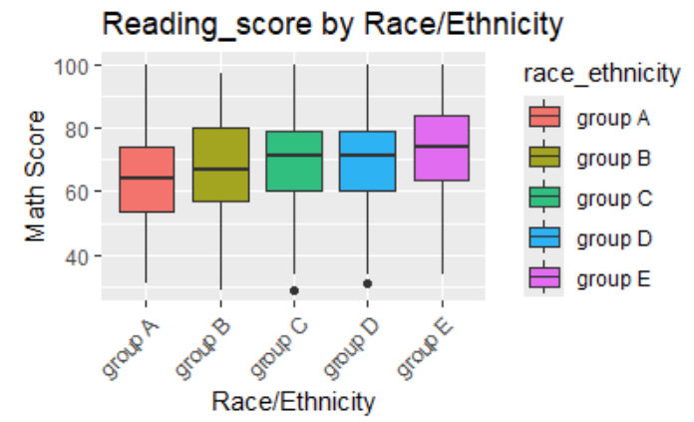

Figure 7: The boxplot of the reading score.

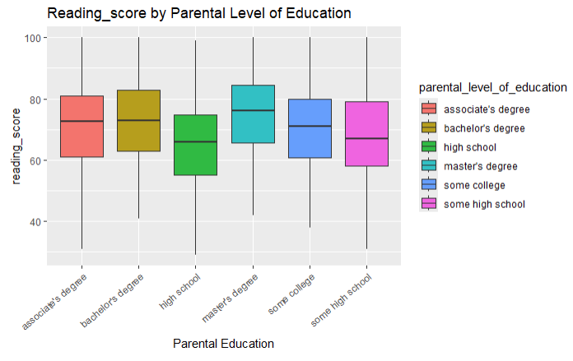

Figure 8: The boxplot of the reading score.

The boxplots illustrate writing scores segregated by gender. Females generally outperform males, evidenced by the higher median and a wider interquartile range, indicating greater consistency in higher performance among females as shown in figure 9. Males display a tighter interquartile range, suggesting less variability in their scores but with some outliers indicating exceptionally low scores as shown in Figure 10. This gender-based disparity highlights differences in academic achievement in writing tasks, suggesting potential areas for educational focus to improve male performance or explore underlying causes such as engagement levels or educational support variations.
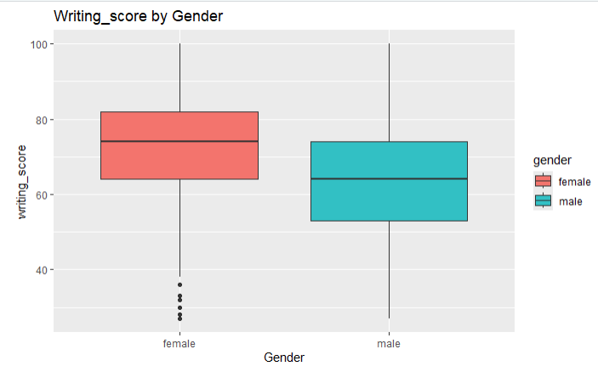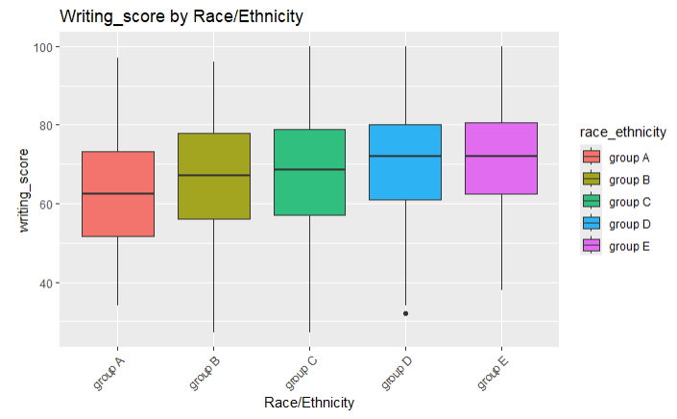

Figure 9: The boxplot of the writing score

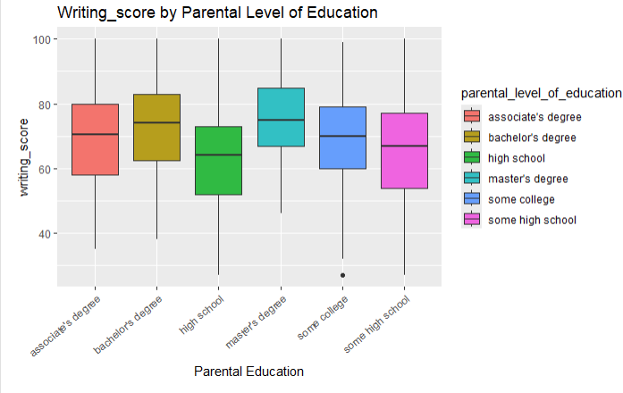

Figure 10: The boxplot of the writing score

4.4 Comparing the 3 scores by the Test Preparation Courses
The boxplot illustrates that students who completed a test preparation course tend to have higher math scores compared to those who did not participate in any preparation course, indicating the potential effectiveness of these courses in improving math performance as shown in Figure 11.

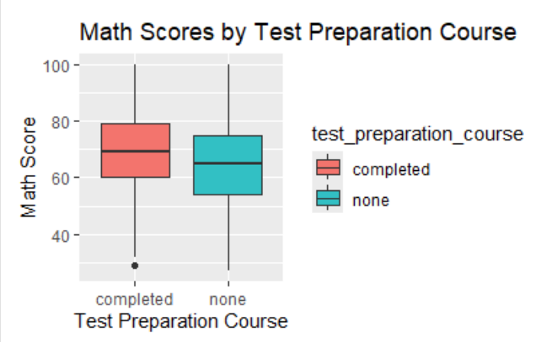

Figure 11: The boxplot math scores by test preparation.

The boxplot shows reading scores by test preparation course status. Students who completed a test preparation course exhibit higher median scores and a tighter score range compared to those who did not partake, suggesting that such preparation likely enhances reading performance as shown in Figure 12.
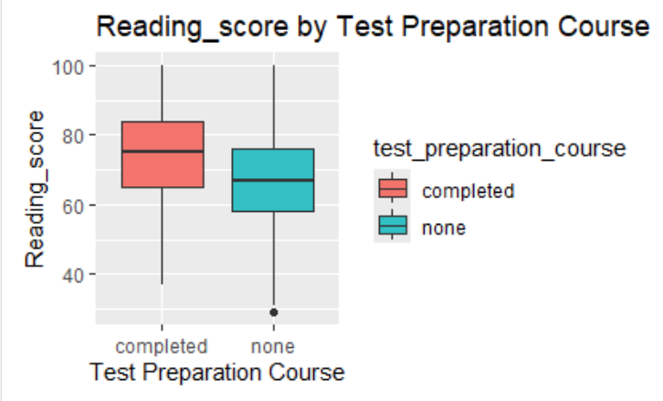

Figure 12: The boxplot reading scores by test preparation.

This boxplot displays the distribution of writing scores based on whether students completed a test preparation course. It reveals that students who completed the course generally achieved higher median writing scores and a narrower score range compared to those who did not participate, indicating the beneficial impact of test preparation on writing outcomes as shown in figure 13.

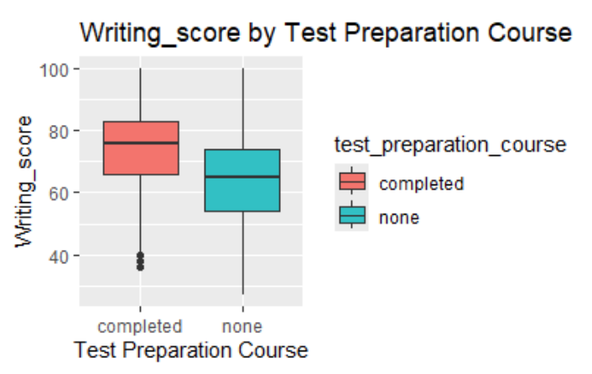
Figure 13: The boxplot writing scores by test preparation.

4.5 The Advance Statistical Analyzing the Impact of Test Preparation Courses
The statistical analysis of math, reading, and writing scores provides compelling evidence of the positive impact of test preparation courses. Using Welch's Two Sample t-test, we find that students who participated in these courses consistently outperformed their peers who did not. In math, the average score for participants was approximately 69.83, compared to 64.60 for non-participants, with a highly significant p-value of about 4.621 × 10−8 and a confidence interval from 3.37 to 7.08. This suggests that engaging in test preparation substantially boosts math scores.
The influence of test preparation is even more pronounced in reading scores. Participants scored an average of 73.89, significantly higher than the 66.94 average for those who did not take the course. The p-value of 5.62 × 10−14 and a confidence interval stretching from 5.17 to 8.74 not only confirm the effectiveness of these courses but also suggest a broader educational impact, potentially influencing students' reading comprehension and learning habits.
Similarly, writing scores analysis underscores the benefits of test preparation, with course participants averaging 74.42 against 64.87 for those who did not participate. The remarkable p-value of less than 2.2 × 10−16, along with a confidence interval from 7.76 to 11.33, highlights the strongest effect among the tested subjects. This differential suggests that test preparation courses particularly enhance students' writing skills, likely through systematic practice and feedback.
These findings underscore the critical role of test preparation courses in not only improving specific academic skills but also in potentially setting a foundation for enhanced overall academic performance. Institutions may consider these results in curriculum planning and resource allocation to maximize educational outcomes. The substantial improvement seen across subjects can help guide educational policies and interventions, ensuring resources are directed where they can make the most significant difference in student achievement as shown in figure 14.
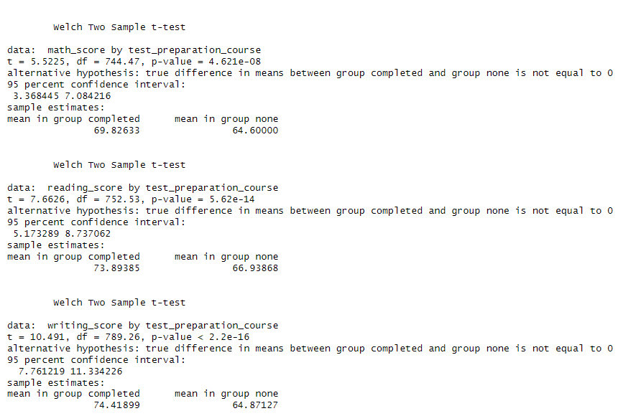
Figure 14: The t-test analysis of the three courses.

4.6 Analyzing Parental Education Level Effects
The analysis using Welch Two Sample t-tests and ANOVA provides a robust statistical basis for understanding the influence of educational interventions and parental background on student performance across various academic subjects. The t-tests reveal that participation in test preparation courses significantly enhances students' performance in math, reading, and writing. This can be attributed to the structured learning and practice provided by these courses, which likely help students develop better test-taking strategies and a deeper understanding of the subject matter.
The p-values from these tests are particularly revealing, with values well below the conventional alpha level of 0.05, indicating a very strong statistical significance. This suggests that the differences in scores are not due to random variation but are likely due to the test preparation itself. The confidence intervals provide a range within which the true mean difference between the groups lies, offering practical insights into the effect size, which is not only statistically significant but also educationally meaningful.
Moreover, the ANOVA results indicate that parental education significantly impacts student performance, with different levels of parental education correlating with varying academic outcomes. This effect is consistent across math, reading, and writing scores, suggesting a broad influence of parental educational background on academic success. The statistical significance of these findings underscores the importance of socio-economic factors in educational achievement, revealing that students with higher-educated parents tend to have better academic outcomes.
The combination of these findings can profoundly impact educational analysis and policymaking. For example, recognizing the significant role of test preparation could lead educational policymakers to advocate for more accessible and extensive test preparation programs, particularly for students from lower socio-economic backgrounds. Similarly, understanding the influence of parental education on student outcomes could drive initiatives aimed at parental involvement programs, which could help bridge the educational performance gap associated with different parental education levels.
These analyses not only highlight critical areas for intervention but also offer a data-driven basis for allocating educational resources more effectively to address disparities and enhance overall student achievement. By integrating these insights into educational strategies, stakeholders can better tailor interventions to meet the diverse needs of students, ultimately leading to improved educational outcomes and more equitable educational opportunities.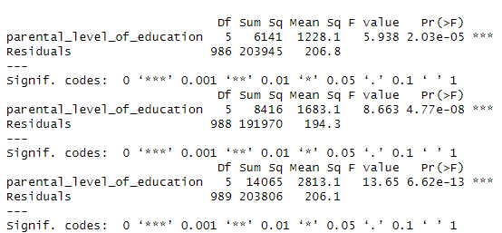
Figure 15: Analyzing Parental Education Level Effects

4.7 Analyzing Racial/Ethnic Group Differences.
The ANOVA results for math, reading, and writing scores based on race/ethnicity indicate significant disparities. Specifically:
- Math Scores: The analysis presents an F-value of 14.19 and a highly significant p-value of 2.91×10−112.91×10−11, indicating strong statistical evidence that race/ethnicity influences math scores. The sum of squares due to race/ethnicity is 11,422, with a mean square of 2,855.5, compared to residuals with a sum of squares at 198,664 and a mean square of 201.3 from 987 degrees of freedom.
- Reading Scores: In reading scores, the F-value is 5.491 with a p-value of 0.000225, which is also significant, underscoring the effect of racial/ethnic differences. The sum of squares for race/ethnicity is 4,354, with a mean square of 1,088.5, whereas residuals show a sum of squares at 196,032 and a mean square of 198.2 across 989 degrees of freedom.
- Writing Scores: Writing scores exhibit an F-value of 6.786 and a p-value of 2.18×10−52.18×10−5, reinforcing the significant impact of race/ethnicity. Here, the sum of squares due to race/ethnicity is 5,814, with a mean square of 1,453.5, and residuals have a sum of squares at 212,057 with a mean square of 214.2 for 990 degrees of freedom.
These statistics robustly demonstrate that racial and ethnic backgrounds play a critical role in influencing student academic outcomes across different subjects. The presence of significant F-values and small p-values across all subjects emphasizes the need to address these disparities through targeted educational policies and interventions aimed at supporting underrepresented groups as shown in figure 16.

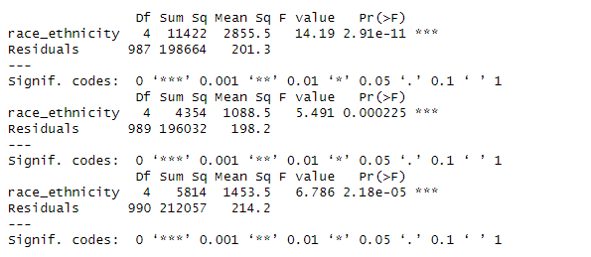
Figure 16: Analyzing Racial/Ethnic Group Differences.

5. Ethical Considerations
In my comprehensive analysis of student performance data, I diligently adhered to stringent ethical standards, prioritizing privacy, objectivity, and the reliability of my findings. This approach was pivotal in providing trustworthy insights for educational policymakers. To ensure the confidentiality of participant information, I thoroughly anonymized the data by removing all personally identifiable information such as names, specific locations, or exact dates. This crucial step, in alignment with well-established guidelines for conducting ethical educational research, effectively mitigates the risk of data misuse.
I adhered strictly to the Family Educational Rights and Privacy Act (FERPA), safeguarding the privacy of student education records. Following the procedures outlined by Daries et al. (2014), I meticulously ensured that my datasets were devoid of any personal identifiers. I also restricted access to the data strictly to members of the research team, which significantly reduces the possibility of data breaches and underscores my commitment to maintaining high ethical standards in my research.
For the analysis itself, I utilized R's robust suite of statistical tools to ensure the accuracy and integrity of my calculations. Particularly, I leveraged the ggplot2 package, lauded by Healy (2018) for its effectiveness in creating accurate and interpretable visualizations. This tool enabled me to produce clear and unbiased graphical representations of data, which is crucial as such visuals can greatly influence how stakeholders interpret the results.
The integrity of my analytical process was further strengthened by a rigorous methodology that included detailed documentation and multiple checks for accuracy. This approach, recommended by Grolemund & Wickham (2016), not only solidifies the scientific validity of my study but also fosters trust among stakeholders by providing a transparent account of the methods employed. I ensured that each phase of my analysis was meticulously documented and subject to rigorous validation, enhancing the reproducibility and reliability of my findings.
In terms of reporting, I took great care to ensure that my presentation of the data was both accurate and devoid of bias. My results were contextualized appropriately, with a candid discussion of any limitations or potential sources of error. This method of reporting aligns with the highest ethical standards and ensures that my conclusions are grounded in reality and communicated clearly. Such transparency helps prevent any misleading interpretations of the data and reinforces the overall integrity of my research.
Moreover, my ethical considerations extended beyond mere compliance with legal standards. I am actively engaged with ethical research practices that not only meet but exceed the usual requirements. For example, my commitment to data privacy and ethical handling of sensitive information serves as a model for responsible research conduct, setting a high benchmark for future educational studies.
Overall, my research exemplifies the critical role that ethics play in the analysis of educational data. By implementing rigorous privacy measures, employing advanced statistical tools, and maintaining an unwavering commitment to transparency in my methodology and reporting, I contribute positively to educational strategies and policies. My dedication to ethical research practices not only complies with professional and legal standards but also enriches the educational research community, fostering a culture of integrity that supports the educational development of students and facilitates the creation of informed effective educational policies. These practices not only safeguard the interests of participants but also enhance the credibility and impact of my findings in the broader educational landscape.
6. Recommendations
To enhance student academic performance, our analysis highlights the importance of three strategic interventions. First, expanding access to test preparation courses is vital. Our data analysis shows that students who participate in these programs generally achieve higher scores across various subjects. Therefore, increasing funding and improving access to these educational resources is essential for boosting student outcomes.
Second, parental involvement plays a critical role in academic success. Research, including a study by Rafiq et al. (2013), demonstrates that children perform better academically when their parents are more educated and actively engaged in their education. Schools need to implement initiatives aimed at enhancing parental engagement, particularly in communities where educational attainment is lower. These programs could involve workshops that provide parents with effective strategies to support their children's education at home, thereby fostering an environment conducive to academic success.
Third, our findings highlight significant performance disparities among different racial and ethnic groups. This points to a pressing need for customized educational interventions tailored to the unique challenges faced by underperforming groups. By establishing targeted support programs, educational institutions can ensure that all students, regardless of their background, have the necessary resources to thrive academically.
Implementing these recommendations could lead to significantly improved educational outcomes and foster a more equitable learning environment. Educational policymakers and school administrators must consider these strategic interventions to enhance academic performance and ensure equal educational opportunities for all students. These steps, if effectively implemented, have the potential to bridge achievement gaps and contribute to a more inclusive educational system.
Such initiatives not only aim to improve academic performance but also strive to create an educational landscape where every student could succeed. By addressing the key areas of test preparation, parental involvement, and targeted support for underserved groups, we can make substantial strides toward an education system that equitably supports all students. This approach is essential for building a foundation that promotes lifelong learning and prepares all students for future success.

7. Conclusions
This detailed analysis has revealed the critical role that external educational support and parental involvement play in improving student outcomes across various metrics, including math, reading, and writing scores. The data indicates that students who participate in test preparation courses typically achieve higher scores, suggesting that these programs are effective in bolstering academic performance. Moreover, the influence of parental education levels on student success is evident, indicating that parental involvement is a significant factor in educational achievements.
Furthermore, the disparities in performance among different racial and ethnic groups highlight the need for tailored educational interventions that address specific challenges faced by these groups. By implementing targeted support programs, educational institutions can ensure that all students, regardless of their background, have the resources and opportunities necessary to succeed.
To further these efforts, it is recommended that educational policymakers and school administrators expand access to test preparation courses, not just as remedial measures but as standard educational enhancements available to all students. Additionally, developing programs that actively involve parents and guardians, especially in communities with historically lower educational attainment, could bridge the gaps in understanding and support that students face at home.
Continued research and ongoing data analysis are crucial in this endeavor. They will allow for the refinement of educational strategies and interventions, adapting them to meet the evolving needs of the student population and the dynamics of the educational environment. This proactive approach in education is essential for fostering an inclusive and equitable learning environment that not only addresses current disparities but also anticipates future challenges, ensuring all students can reach their full potential.

8. References
Blackwell, L. S., Trzesniewski, K. H., & Dweck, C. S. (2007). Implicit theories of intelligence predict achievement across an adolescent transition: A longitudinal study and an intervention. Child Development, 78(1), 246-263.
Daries, J. P., Reich, J., Waldo, J., Young, E. M., Whittinghill, J., Ho, A. D., Seaton, D. T., & Chuang, I. (2014). Privacy, anonymity, and big data in the social sciences. Communications of the ACM, 57(9), 56-63.
Davis-Kean, P. E. (2005). The influence of parent education and family income on child achievement: The indirect role of parental expectations and the home environment. Journal of Family Psychology, 19(2), 294.
Grolemund, G., & Wickham, H. (2016). R for data science. Hadley Wickham.
Healy, K. (2018). Data visualization: A practical introduction. Princeton University Press.
James, G., Witten, D., Hastie, T., & Tibshirani, R. (2013). An introduction to statistical learning. Springer.
Konstantopoulos, S. (2009). Effects of teachers on minority and disadvantaged students' achievement in the early grades. The Elementary School Journal, 110(1), 92-113.
Rafiq, H. M. W., Fatima, T., Sohail, M. M., Saleem, M., & Khan, M. A. (2013). Parental involvement and academic achievement: A study on secondary school students of lahore, pakistan. International Journal of Humanities and Social Science, 3(8), 209-223.
Reardon, S. F. (2018). The widening academic achievement gap between the rich and the poor. Social stratification (pp. 536-550). Routledge.
Wickham, H., & Wickham, H. (2016). Data analysis. Springer.

